*Sport Economics Research*

*2025, VOL. 2, NO. 1, X-X*

[*https://doi.org/*](https://doi.org/)



## 

*Research Article/Review*

Tittle Sport Economics Research (Times New Roman 24 p.)

**Abstract**

Sport economics research. Sport economics research. Sport economics research. Sport economics research. Sport economics research. Sport economics research. Sport economics research. Sport economics research. Sport economics research. Sport economics research. Sport economics research. Sport economics research. Sport economics research. Sport economics research. Sport economics research. Sport economics research. Sport economics research. Sport economics research. Sport economics research. Sport economics research. Sport economics research. Sport economics research. Sport economics research. Sport economics research. Sport economics research. Sport economics research. Sport economics research. Sport economics research. Sport economics research. Sport economics research. Sport economics research. Sport economics research. Sport economics research. Sport economics research. Sport economics research. Sport economics research. Sport economics research. Sport economics research. Sport economics research. Sport economics research. Sport economics research. Sport economics research. Sport economics research. Sport economics research. Sport economics research. Sport economics research. Sport economics research. Sport economics research. Sport economics research. Sport economics research. Sport economics research. (Max. 200 words, Times New Roman 10p)

**Keywords**

Sport, sport economics, sport economics (3-5 key words)

# **Introduction (Title, 12p, Bold)**

S

por economics. Spor economics. Spor economics. Spor economics. Spor economics. Spor economics. Spor economics. Spor economics. Spor economics. Spor economics. Spor economics. Spor economics. Spor economics. Spor economics. Spor economics. Spor economics. Spor economics. Spor economics. Spor economics. Spor economics. Spor economics. Spor economics. Spor economics. Spor economics. Spor economics (Sporteconres, 2023).

Spor economics. Spor economics. Spor economics. Spor economics. Spor economics. Spor economics. Spor economics. Spor economics. Spor economics. Spor economics. Spor economics. Spor economics. Spor economics Spor economics. Spor economics. Spor economics. Spor economics. Spor economics. Spor economics. Spor economics. Spor economics. Spor economics. Spor economics. Spor economics. Spor economics. Spor economics. Spor economics. Spor economics. Spor economics. Spor economics. Spor economics. Spor economics. Spor economics. Spor economics (Sporteconres, 2024).

**Method (Title, 12p, Bold)**

*Description of X Form (Title, 11p, Italic)*

*Study Design and Participants (Title, 11p, Italic)*

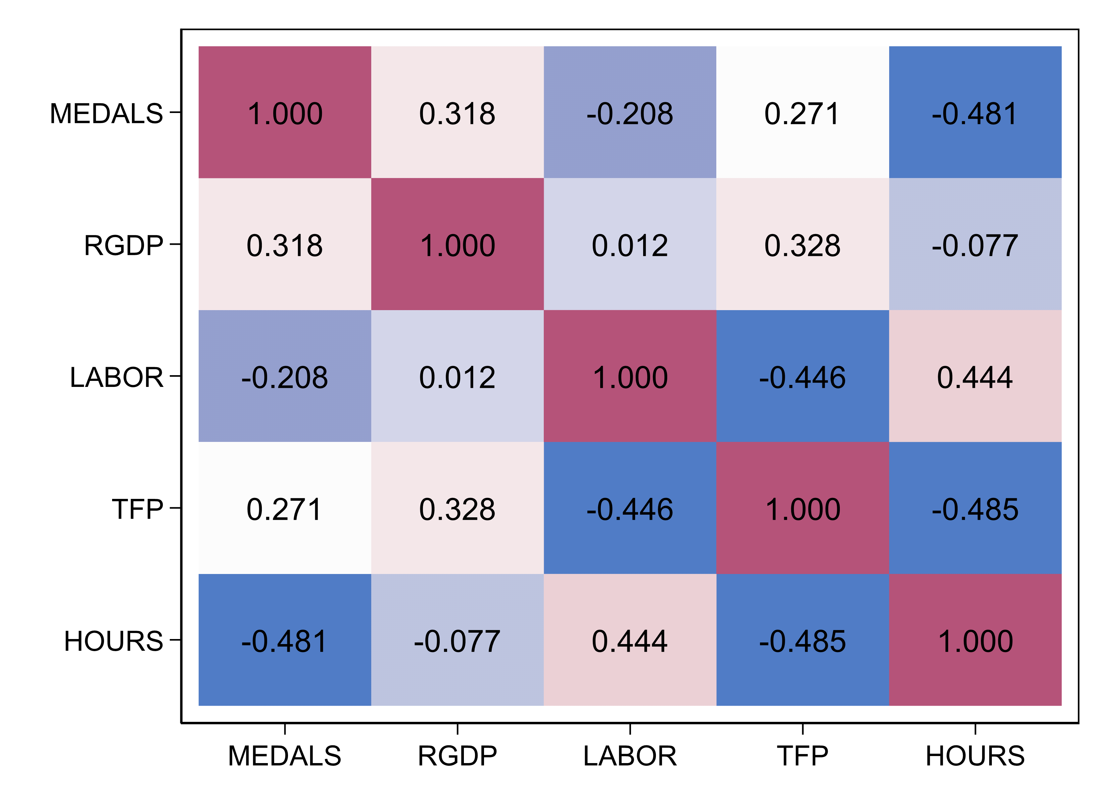

**Fig 1.** Sport economics research (Times New Roman, 10p)

Spor economics. Spor economics. Spor economics. Spor economics. Spor economics. Spor economics. Spor economics. Spor economics. Spor economics. Spor economics. Spor economics. Spor economics. Spor economics Spor economics (Fig 1.).

**Table 1.** Sport economics research (Times New Roman, 10p)

|  |  |  |  |  |  |
| --- | --- | --- | --- | --- | --- |
| Variable | Obs | Mean | Std. dev. | Min | Max |
| *MEDAL* | 185 | 23.34028 | 18.6522 | 10.77505 | 16.81765 |
| *RGDP* | 185 | 23.34028 | 18.6522 | 10.77505 | 16.81765 |
| *LABOR* | 185 | 23.34028 | 18.6522 | 10.77505 | 16.81765 |
| *TFP* | 185 | 23.34028 | 18.6522 | 10.77505 | 16.81765 |
| *HOURS* | 185 | 23.34028 | 18.6522 | 10.77505 | 16.81765 |

Spor economics. Spor economics. Spor economics. Spor economics. Spor economics. Spor economics. Spor economics. Spor economics. Spor economics. Spor economics. Spor economics. Spor economics. Spor economics Spor economics (Table 1.).

**Discussion (Title, 12p, Bold)**

**Conclusions (Title, 12p, Bold)**

**References (Title, 12p, Bold)**

Aron, L., Botella, M., & Lubart, T. (2019). Culinary arts: Talent and their development. In R. F. Subotnik, P. Olszewski-Kubilius, & F. C. Worrell (Eds.), *The psychology of high performance: Developing human potential into domain-specific talent* (pp. 345–359). American Psychological Association. https://doi.org/10.1037/0000120-016

Evans, A. C., Jr., Garbarino, J., Bocanegra, E., Kinscherff, R. T., & Márquez-Greene, N. (2019, August 8–11). *Gun violence: An event on the power of community* [Conference presentation]. APA 2019 Convention, Chicago, IL, United States. https://convention.apa.org/2019-video

Grady, J. S., Her, M., Moreno, G., Perez, C., & Yelinek, J. (2019). Emotions in storybooks: A comparison of storybooks that represent ethnic and racial groups in the United States. *Psychology of Popular Media Culture,8*(3), 207–217. https://doi.org/10.1037/ppm0000185

National Institute of Mental Health. (2018, July). *Anxiety disorders.* U.S. Department of Health and Human Services, National Institutes of Health. <https://www.nimh.nih.gov/health/topics/anxiety-disorders/index.shtml>